
We announce the 16th edition of the International Conference The Future of Education 2026:
17 June 2026 | Online Event via the Conference Virtual Platform
18 - 19 June 2026 | in Florence, Italy
The Call for Papers is open to teachers, researchers and experts in the field of innovation in education, as well as to coordinators of pioneering education projects.
Participants can attend the Conference onsite (in Florence, Italy) or online from anywhere in the world - either as Presenters or as Listeners. Join a vibrant global dialogue on cutting-edge teaching and learning methodologies, and contribute to shaping the future of education.

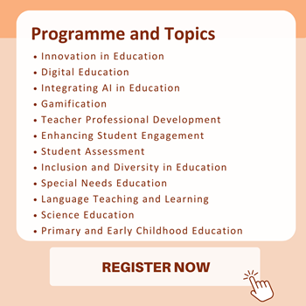
WHY PRESENT AT FOE 2026?
To gain academic visibility by having your paper:
- Indexed in Google Scholar and Academia.edu.
- Published in the Conference Proceedings e-book with ISBN, ISSN and DOI codes.
- Reviewed for possible inclusion in Web of Science and SCOPUS*.
- Made available in open access in the Conference Digital Library.
*The Conference Proceedings of “The Future of Education 2025 – International Conference” have been officially accepted for inclusion in SCOPUS.
WHAT TO EXPECT?
- Live Paper Presentations, either onsite and online.
- Interactive Q&A Sessions following each talk.
- Poster Presentation Sessions organized onsite and online.
- Networking Opportunities and Social Events to foster meaningful connections.
KNOW SOMEONE WHO MIGHT BE INTERESTED?
We encourage you to forward this invitation to colleagues in your department or academic network who may also wish to contribute to the Conference.
Together, let’s shape a more innovative, inclusive, and impactful future for education.

What do our participants and speakers have to say about their experiences at the Conference?
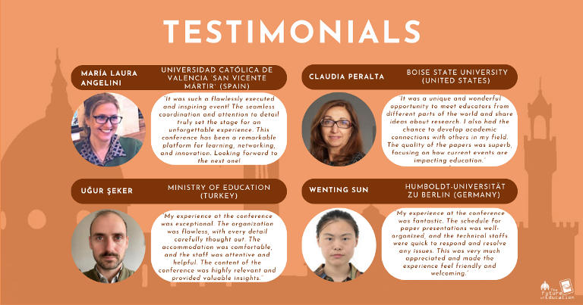
SAVE THE DATE - SHAPE THE FUTURE OF EDUCATION WITH US!
17 JUNE 2026 | ONLINE EVENT
18 - 19 JUNE 2026 | IN FLORENCE (ITALY)

