ACADEMIA SLOVENIA 2025

Exchange of practices and cooperation in lifelong guidance

7-10 April 2025

Ljubljana and Naklo, Slovenia

Final agenda

Host:
Euroguidance Slovenia, Employment Service of Slovenia

The program will introduce Slovenian guidance system, Slovenian labour market and Employment Service of Slovenia as well as guidance in different settings. The participants will have possibilities for discussions about various guidance related issues among guidance practitioners to exchange guidance practices among themselves and other experts.

The participating guidance practitioners will:

- gain overview of lifelong guidance and service provision for different target groups in Slovenia;
- be able to understand learning in a multicultural environment;
- teach and learn from peers on the guidance topics with exchange of practices;
- be able to practice professional language and participate in discussions;
- widen the international professional network.

Monday, 7 April 2025
Facilitator: Sabina Škarja MSc

Meeting place 9.00: B&B Hotel Ljubljana Park
Public transport to the meeting place provided by Euroguidance Slovenia

9.30-10.00
Arrival of the participants, welcome by the host and pre-activity survey, Sabina Škarja MSc

10.00-10.30
Euroguidance Slovenia, National Vocational Information and Counselling Centre, Sabina Škarja MSc

10.30-12.00
The Employment Service of Slovenia and Slovenian labour market, Viljem Spruk

Networking lunch provided by Euroguidance Slovenia

13.00-15.00
Career guidance tools and services at the Employment Service of Slovenia, Anita Troha Ferjančič, Magda Balek Resman, Neža Sebal Francelj

16.00-18.00
Networking and walking tour of Ljubljana old town

Tuesday, 8 April 2025
Facilitator: Sabina Škarja MSc

Meeting place 8.15: B&B Hotel Ljubljana Park
Transport to meeting places provided by Euroguidance Slovenia

9.00-12.00
Biotechnical Center Naklo, Jerneja Rozman, Tibor Brvar

Networking lunch provided by Euroguidance Slovenia

14.00-16.00
Guidance in adult education centres, Tanja Vilič Klenovšek MSc
Visit to the Guidance centre Ljubljana, JZ Cene Štupar

Wedensday, 9 April 2025
Facilitator: Sabina Škarja MSc

Meeting place at 8.15: B&B Hotel Ljubljana Park
Transport to the meeting place provided by Euroguidance Slovenia

9.00-9.30
KULT 316 learning environment of the Biotechnical Educational Centre Ljubljana, Tomaž Leben

9.30-10.30
Exploring career through playful learning, Sara Gošnak

10.30-16.00
Exchange of good practices and discussions

10.30-10.45
The Top Civil Service Excellence Centre,
Monika Tamla, Riigikantselei, Republic of Estonia Government Office, Estonia

10.45-11.00
Career Choice Mapping Method – Passion, Competencies, Possibilities,
Mirjam Roasto, Education and Youth Board, Estonia

11.00-11.15
A workshop for career orientation: What professions are out there?
Lena Bethmann, Agentur für Arbeit Berlin Süd, Germany

11.15-11.30
How adults catch up with the aid of dual vocational education and training (VET) qualification?
Petra Hovi, Agentur für Arbeit Köln, Germany

11.30-11.45

Health break

12.00-12.15
Limerick and Clare Education and Training Board,
Michael Donnellan, Limerick & Clare Education & Training Board, Ireland

12.15-12.45
Guidance Counselling Practices in an Irish Post-Primary School
Frank Colohan and Emma O’Roarke, Abbey Community College Boyle, Ireland

12.45-13.00
Career and Educational Counselling at Øksnevad Upper Secondary School,
Dag Thomas Kvalvik, Øksnevad videregående skole, Norway

13.00-13.15
Project-Based Learning in FOL (Formación y Orientación Laboral/Training and Job Guidance): Boosting Student Motivation for Professional Integration through Theatrical Representation of Workplace Situations and Conflicts,
David Molina Pérez, Institut de Logística de Barcelona, Spain

13.15-13.30
Questions and answers

Networking lunch provided by Euroguidance Slovenia

15.30-16.00
Discussions and wrap up the day, Sabina Škarja MSc

Thursday, 10 April 2025
Facilitator: Sabina Škarja MSc

Meeting place at 8.40: B&B Hotel Ljubljana Park
Walk to the meeting place

9.00-10.30
Career centres of the University of Ljubljana, Maja Dizdarević, Jelena Ličanin

Walk to the meeting place

11.00-12.30
NEETs service for youth, Mateja Pačnik Kolenc

12.30-13.30
Evaluation, post-activity survey and certificates, Sabina Škarja MSc

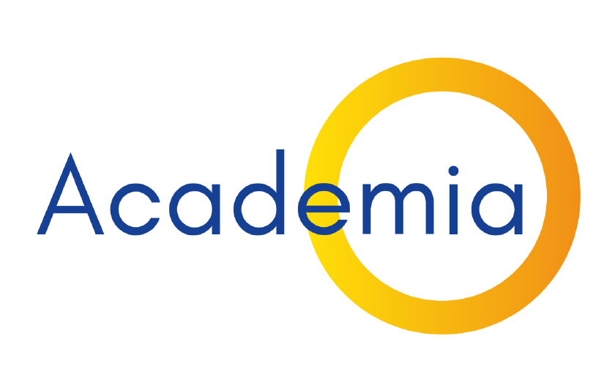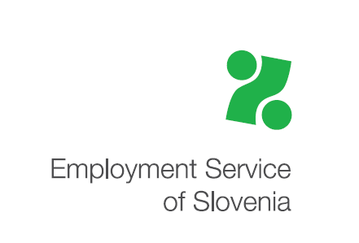

* Funded by the European Union. Views and opinions expressed are however those of the author(s) only and do not necessarily reflect those of the European Union or the European Education and Culture Executive Agency (EACEA). Neither the European Union nor EACEA can be held responsible for them.

